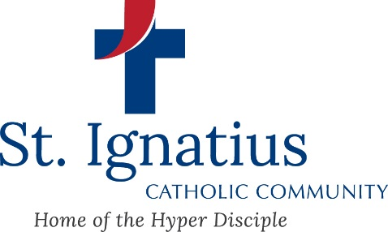

Dear Friends,
We look forward to celebrating your child's Baptism with you!

To help us prepare for this special celebration, the "Baptismal Packet" must be completed and returned to the Parish Office a week prior to the baptism.

The first form is the Baptismal Information, which gives us necessary information regarding the child to be baptized and his/her parents. Please note that if you are not a member of St. Ignatius, you will need to have the pastor of your parish sign, date, and seal the form.

The second form (two copies) is for the chosen godparents to fill out. Please keep in mind that both godparents must be Christian, and at least one must be Catholic. If the godparent is Catholic, they will need to have the pastor of the Catholic Church where they are registered sign and seal the form. If one godparent is non-Catholic, they only need to fill out the top of the form. Once the forms have been completed, please return them to the Parish Office.

If this is your first child to be baptized, you must attend an instructional baptism class that is held on the second Sunday of every other month (January, March, May, July, September, and November) at 10:00 am. Call the Parish Office to reserve your spot.

Please call Lisa at the Parish Office to schedule the baptism at 419-693-1150.

If you have any questions, please call the Parish Office at 419-693-1150. We look forward to celebrating this beautiful sacrament with your child, you, and your families!

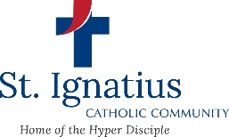
BAPTISMAL SPONSOR INFORMATION
(You must print 2 and fill one out for each sponsor.)

According to Canon Law the following regulations apply for those who which to be considered a sponsor for the Sacrament of Baptism:
- “There is to be only one male sponsor or one female sponsor or one of each” (c. 873)
- A sponsor must “be designated by the one to be baptized, by the parents or the person who take their place, or in their absence by the pastor or minister and have the aptitude and intention of fulfilling this function.” (c. 874.1.1)
- A sponsor must “have completed the sixteenth year of age…” (c. 874.1.2)
- A sponsor must “be a Catholic who has been confirmed and has already received the most holy sacrament of the Eucharist and who leads a life of faith in keeping with the function to be taken on.” (c. 874.1.3)
- A sponsor may “not be bound by any canonical penalty legitimately imposed or declared, [and may] not be the father or mother of the one to be baptized.” (c. 874.1.4 & 5)
- “A baptized person who belongs to a non-Catholic ecclesial community is not to participate except with a Catholic sponsor and then only as a witness of the baptism” (Note: the baptized, non-Catholic will be listed as a “Christian Witness” in the baptismal record.) (c. 874.2)

Name of person to be baptized: _______________________________________

Signature of Sponsor, attesting that he/she is qualified, accepts the responsibility and is registered in a Catholic Parish:

______________________________________________
Print sponsor’s name & address ______________________________________________
______________________________________________

The above individual has the necessary qualification according to the Code of Canon Law of
the Catholic Church to be a baptismal sponsor.

Signature of the Sponsor’s Parish Priest: ___________________________________
Printed Name of Priest: ___________________________________
Name of Parish ___________________________________
Address of Parish ___________________________________
___________________________________
PARISH SEAL This certificate is valid when it bears the signature of the sponsor and parish verification.
BAPTISMAL SPONSOR INFORMATION
(You must print 2 and fill one out for each sponsor.)

According to Canon Law the following regulations apply for those who which to be considered a sponsor for the Sacrament of Baptism:
- “There is to be only one male sponsor or one female sponsor or one of each” (c. 873)
- A sponsor must “be designated by the one to be baptized, by the parents or the person who take their place, or in their absence by the pastor or minister and have the aptitude and intention of fulfilling this function.” (c. 874.1.1)
- A sponsor must “have completed the sixteenth year of age…” (c. 874.1.2)
- A sponsor must “be a Catholic who has been confirmed and has already received the most holy sacrament of the Eucharist and who leads a life of faith in keeping with the function to be taken on.” (c. 874.1.3)
- A sponsor may “not be bound by any canonical penalty legitimately imposed or declared, [and may] not be the father or mother of the one to be baptized.” (c. 874.1.4 & 5)
- “A baptized person who belongs to a non-Catholic ecclesial community is not to participate except with a Catholic sponsor and then only as a witness of the baptism” (Note: the baptized, non-Catholic will be listed as a “Christian Witness” in the baptismal record.) (c. 874.2)

Name of person to be baptized: _______________________________________

Signature of Sponsor, attesting that he/she is qualified, accepts the responsibility and is registered in a Catholic Parish:

______________________________________________
Print sponsor’s name & address ______________________________________________
______________________________________________

The above individual has the necessary qualification according to the Code of Canon Law of
the Catholic Church to be a baptismal sponsor.

Signature of the Sponsor’s Parish Priest: ___________________________________
Printed Name of Priest: ___________________________________
Name of Parish ___________________________________
Address of Parish ___________________________________
___________________________________
PARISH SEAL This certificate is valid when it bears the signature of the sponsor and parish verification.
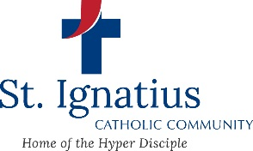
Date of Baptism: _________________________

BAPTISMAL INFORMATION
212 N. Stadium Rd. Oregon, OH 43616

Please print legibly:

Name of person to be baptized: ________________________________________________ BOY/ GIRL
Last First Middle

Date of Birth: _______________________ Place of birth: ____________________________________
Month/ Day/ Year Location/ City/ State

Father’s Name: ______________________________________________________________________
Last/ First/ Middle Father’s religion: Catholic Non-Catholic

Mother’s Name: ______________________________________________________________________
Last/ First/ Middle/ MAIDEN Mother’s religion: Catholic Non-Catholic

Home address: _______________________________________________________________________
Street City State Zip

Phone: _____________________________________________________________________________
Home Cell

Male Baptismal Sponsor: ___________________________________ Catholic Non-Catholic

Female Baptismal Sponsor: ___________________________________ Catholic Non-Catholic

PLEASE COMPLETE
*Has this child ever been baptized in any religion: Yes No If yes, where __________________
*I am / We are: Single Married If Married, Church: _________________ Date: _____________
*Has either spouse been married before: Yes No
*If previously married, was previous marriage(s) annulled by the Catholic Church Yes No

If you are not a member of St. Ignatius please fill out the following: Name & Address of your Catholic Parish___________________________________________________________________________________________________________________________________________________________________

*************************************************************************************
For Parish Use:
Schedule baptism on parish calendar Parents attended baptism class
Sponsor paperwork to parish office Input in baptismal book
Input in database Certificate

Notes:_________________________________________________________________________________________________________________________________________________________________

Date Sacrament of Baptism Administer: _________________ Celebrant: _______________________

